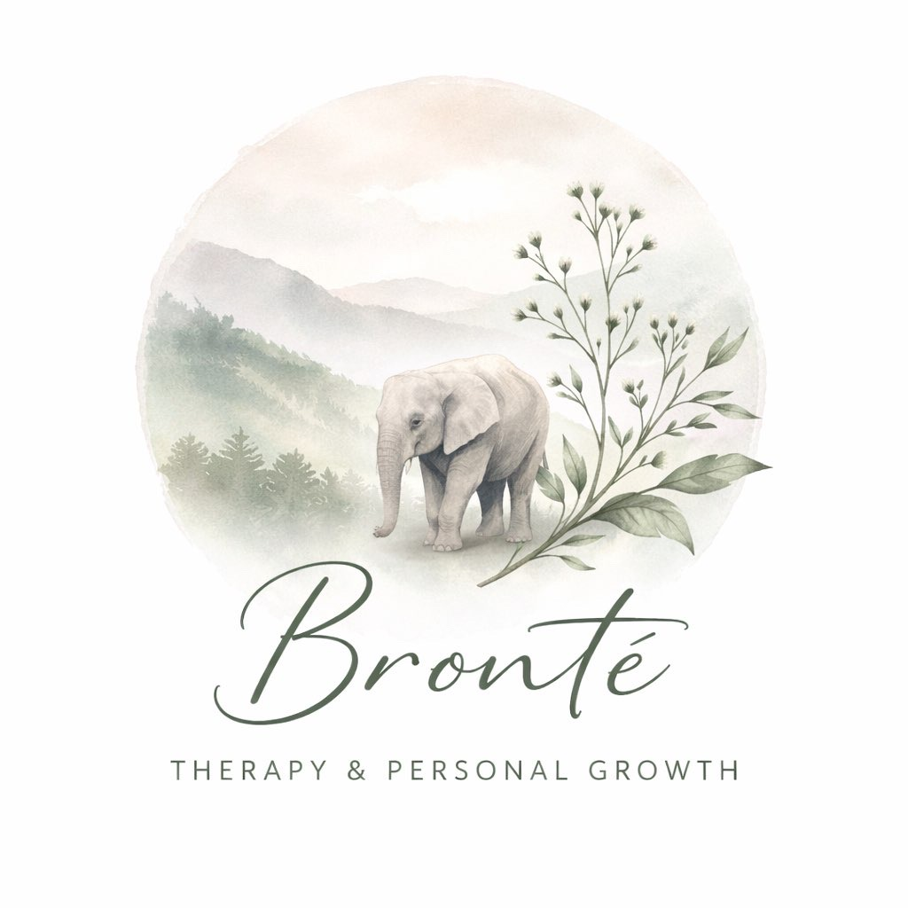

Privacy Policy – Bronte Therapy

Effective date
07th March 2026

Introduction
Bronte Therapy is committed to protecting your privacy and handling your personal data in a transparent and secure way. This Privacy Policy explains how we collect, use, store, and protect your personal information when you contact us or engage in therapy services. This policy follows UK GDPR and the Data Protection Act 2018.

1. Who We Are
Bronte Therapy provides counselling and therapeutic services.
Data Controller: Charlotte Walters
Bronte Therapy
Info@brontetherapy.co.uk
07346808529

The data controller is responsible for deciding how your personal information is used and stored.

2. What Information We Collect
Personal Information:
- Name
- Date of birth
- Address
- Email address
- Telephone number
- Emergency contact details

Health and Therapy Information:
- Information about your mental health
- Medical history relevant to therapy
- Therapy notes and session records
- Information you share during sessions

Administrative Information:
- Appointment records
- Payment information
- Correspondence (emails, texts)

3. How We Collect Your Data
Your information may be collected when you:
- Contact us via phone, email, socials, WhatsApp or website
- Complete intake or assessment forms
- Attend therapy sessions
- Make payments for services
- Communicate with us between sessions

4. How We Use Your Information
Your information is used to:
- Provide counselling and therapy services
- Maintain accurate client records
- Communicate with you about appointments
- Ensure safe and ethical practice
- Comply with legal and professional obligations

5. Lawful Basis for Processing
Under UK GDPR, the lawful bases we rely on include:
- Contract: to provide therapy services you have requested
- Legitimate interests: maintaining client records and managing appointments
- Legal obligation: complying with professional, legal, and safeguarding duties
- Special category data: health information processed for the provision of healthcare services

6. Confidentiality
Everything discussed in therapy is treated as confidential. However, confidentiality may be broken in the following circumstances:
- If there is a serious risk of harm to you or another person
- If safeguarding concerns arise involving a child or vulnerable adult
- If required by law or court order
- As part of professional supervision (your identity will not normally be disclosed)

7. How We Store Your Data
Your information is stored securely and may include:
- Password-protected digital files
- Secure practice management systems
- Locked filing systems for paper records

We take reasonable steps to ensure your data is protected from loss, misuse, or unauthorised access.

8. How Long We Keep Your Data
Client records are normally kept for 7 years after the end of therapy. After this time, records are securely destroyed or deleted in line with professional standards.

9. Sharing Your Information
Your information will not be shared with third parties without your consent except where:
- Required by law
- There is risk of serious harm
- Safeguarding responsibilities apply
- Professional supervision is required

Any supervision discussions will anonymise identifying information wherever possible.

10. Your Data Protection Rights
Under UK GDPR, you have the right to:
- Access your personal data
- Request correction of inaccurate information
- Request deletion of your data (in some circumstances)
- Restrict processing of your data
- Object to certain types of processing
- Request transfer of your data

11. Complaints
If you have concerns about how your data is handled, please contact Bronte Therapy first. You also have the right to lodge a complaint with the Information Commissioner's Office (ICO).

12. Changes to This Privacy Policy
This policy may be updated occasionally to reflect changes in law or professional practice. The latest version will always be available on request.

